**A. Get all the countries from Asia continent using Filter function:**

**Program:**

<!DOCTYPE html>

<html lang="en">

<head>

<meta charset="UTF-8">

<meta http-equiv="X-UA-Compatible" content="IE=edge">

<meta name="viewport" content="width=device-width, initial-scale=1.0">

<title>Rest countries</title>

</head>

<body>

<h1>Using restcountries API url, displaying all the countries from Asia continent using Filter function</h1>

<script>

function reqListener() {

let countryData=JSON.parse(this.response);

const result=countryData.filter((element)=>{

if(element.region==='Asia'){

return element.name.common;

}

})

console.log(result);

}

const req = new XMLHttpRequest();

req.addEventListener("load", reqListener);

req.open("GET", "https://restcountries.com/v3.1/all");

req.send();

</script>

</body>

</html>

Result:

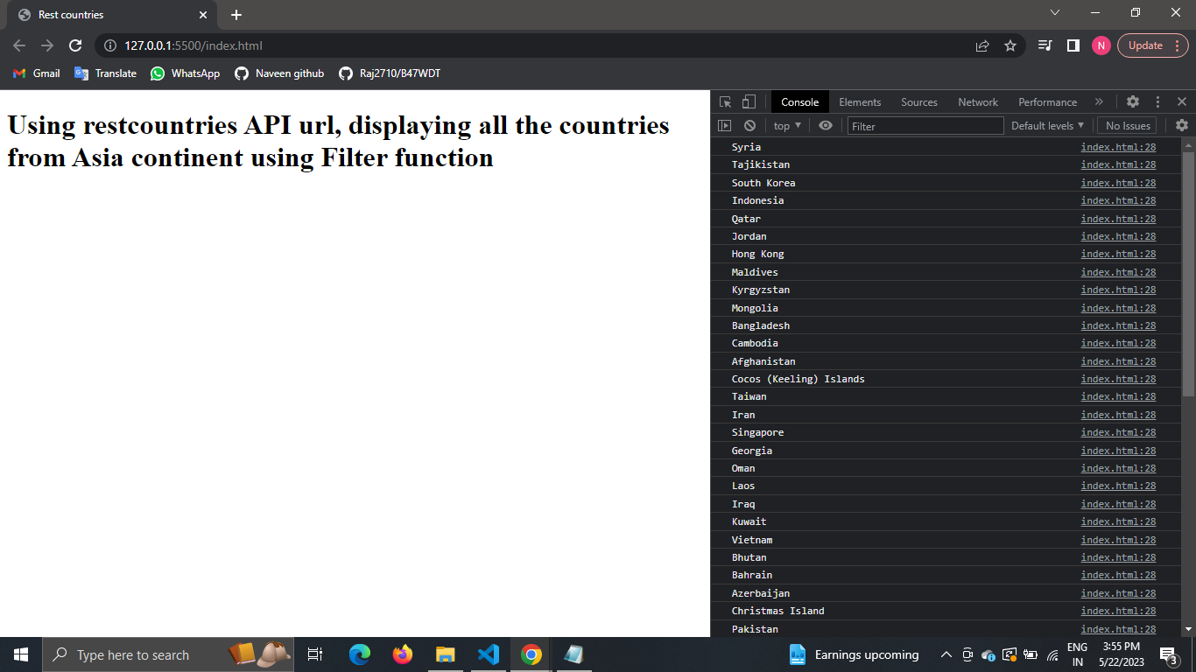

—---------------------------------------------------------------------------------------------------------------------------------------

**B. Get all the countries with population of less than 2 lakhs using filter function:**

**Program:**

<!DOCTYPE html>

<html lang="en">

<head>

<meta charset="UTF-8">

<meta http-equiv="X-UA-Compatible" content="IE=edge">

<meta name="viewport" content="width=device-width, initial-scale=1.0">

<title>Rest countries</title>

</head>

<body>

<h1>Using restcountries API url, displaying all the countries with population of less than 2 lakhs using Filter function</h1>

<script>

function reqListener() {

var countryData=JSON.parse(this.response);

const popu=countryData.filter((element)=>{

return element.population<200000;

})

console.log(popu);

}

const req = new XMLHttpRequest();

req.addEventListener("load", reqListener);

req.open("GET", "https://restcountries.com/v3.1/all");

req.send();

</script>

</body>

</html>

Result:

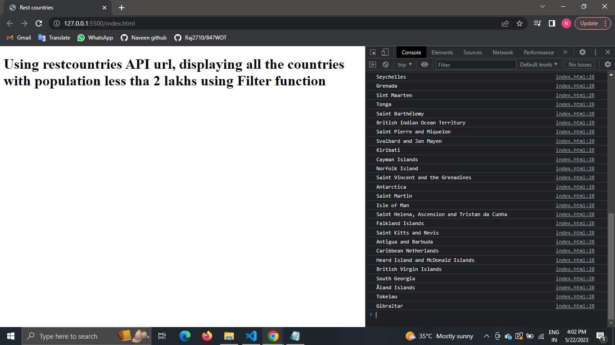

—---------------------------------------------------------------------------------------------------------------------

**C. Printing Name, Capital and Flag using foreach function:**

**Program:**

<!DOCTYPE html>

<html lang="en">

<head>

<meta charset="UTF-8">

<meta http-equiv="X-UA-Compatible" content="IE=edge">

<meta name="viewport" content="width=device-width, initial-scale=1.0">

<title>Rest countries</title>

</head>

<body>

<h1>Printing Name, Capital and Flag using foreach</h1>

<script>

function reqListener() {

var countryData=JSON.parse(this.response);

countryData.forEach((element)=>{

console.log(element.name,element.capital,element.flag);

})

}

const req = new XMLHttpRequest();

req.addEventListener("load", reqListener);

req.open("GET", "https://restcountries.com/v3.1/all");

req.send();

</script>

</body>

</html>

Result:

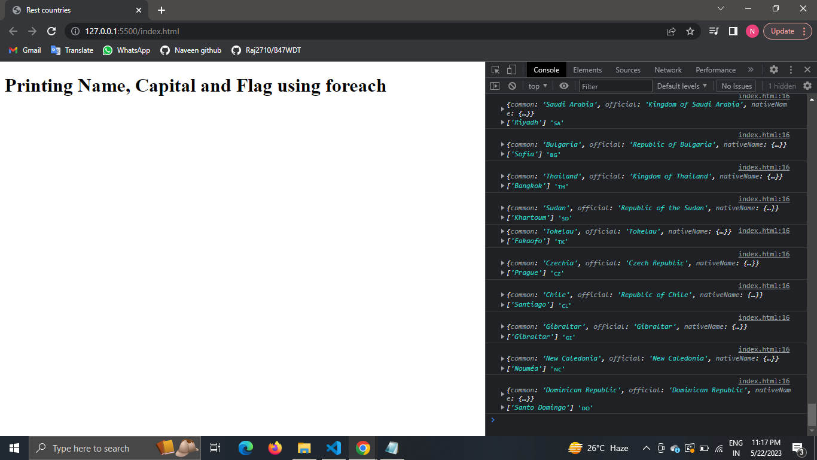

—--------------------------------------------------------------------------------------------------------------------------

**D. Print the total population of countries using reduce function:**

**Program:**

<!DOCTYPE html>

<html lang="en">

<head>

<meta charset="UTF-8">

<meta http-equiv="X-UA-Compatible" content="IE=edge">

<meta name="viewport" content="width=device-width, initial-scale=1.0">

<title>Rest countries</title>

</head>

<body>

<h1>Print the total population of countries using reduce function </h1>

<script>

function reqListener() {

var countryData=JSON.parse(this.response);

const population=countryData.reduce((acc,element)=>{

return acc+element.population;

},0)

console.log(population);

}

const req = new XMLHttpRequest();

req.addEventListener("load", reqListener);

req.open("GET", "https://restcountries.com/v3.1/all");

req.send();

</script>

</body>

</html>

Result:

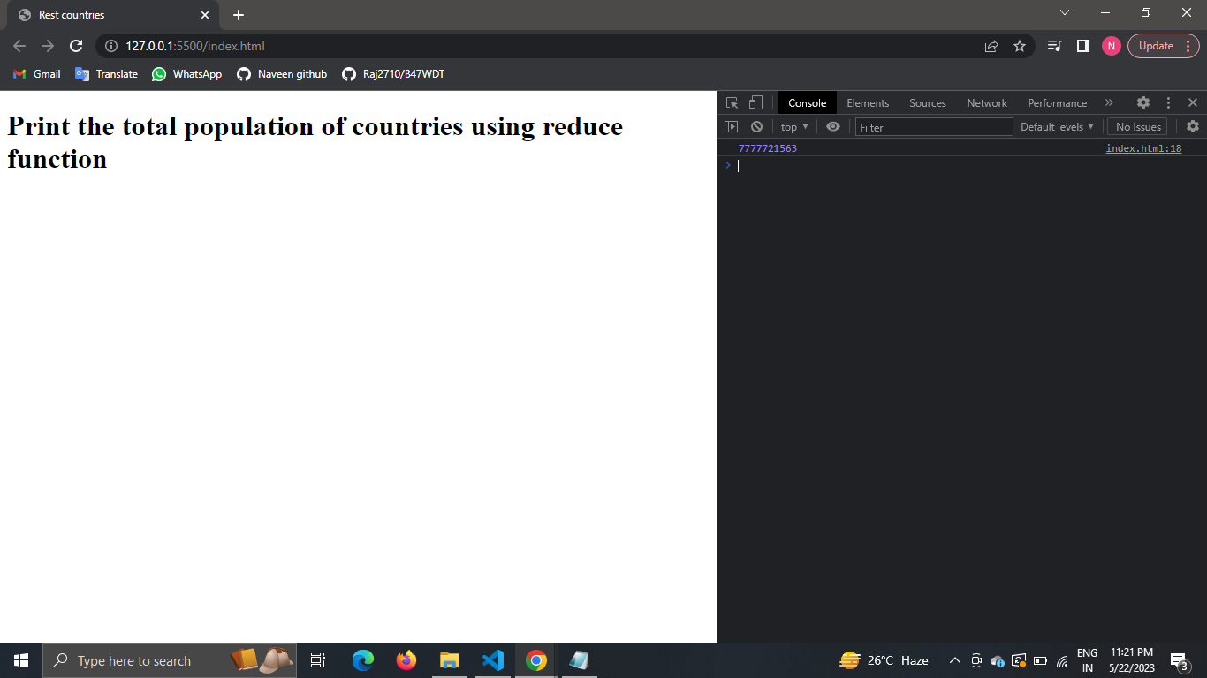

—-------------------------------------------------------------------------------------------------------------------

**E. Print the country which use US Dollars as currency:**

**Program:**

<!DOCTYPE html>

<html lang="en">

<head>

<meta charset="UTF-8">

<meta http-equiv="X-UA-Compatible" content="IE=edge">

<meta name="viewport" content="width=device-width, initial-scale=1.0">

<title>Rest countries</title>

</head>

<body>

<h1>Print the country which use US Dollars as currency</h1>

<script>

function reqListener() {

let data = JSON.parse(this.response);

let cur=[];

for(let i=0;i<data.length;i++){

if(data[i].currencies.USD.name == "United States dollar"){

console.log(`Name: ${data[i].name.common} ==> ${data[i].currencies.USD.name}`);

}

}

}

const req = new XMLHttpRequest();

req.addEventListener("load", reqListener);

req.open("GET", "https://restcountries.com/v3.1/all");

req.send();

</script>

</body>

</html>

Result:

United States America

—-------------------------------------------------------------------------------------------------------------